IPC-I1150P04-02 Desktop Motherboard

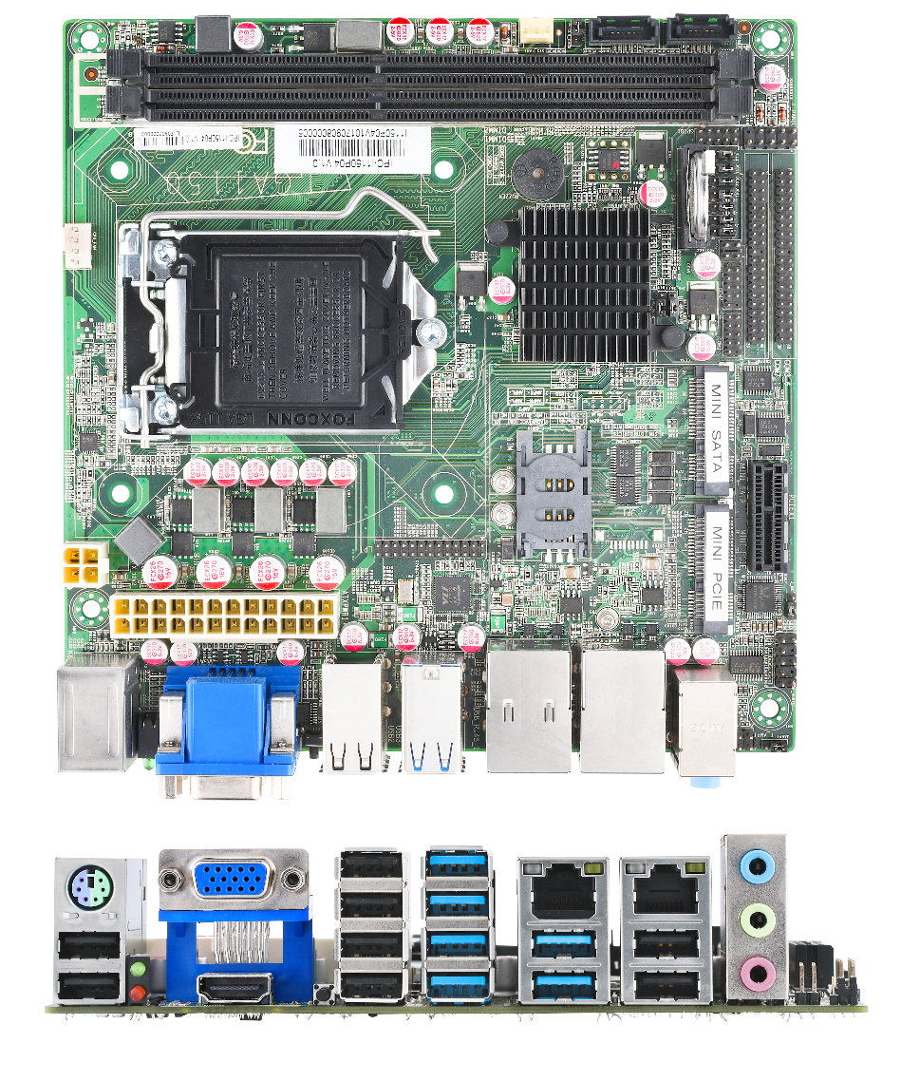

Features
Intel Haswell high-speed processor
LGA 1150 Port MINI Industrial embedded motherboard
Support VGA+HMDI synchronous/asynchronous display
Support DDR3 desktop memory Support 10*COM
Support 14*USB Onboard 1*MSATA port
Onboard 1*MINIPCIE
Application
Industrial Automation、Rail Transportation、Financial Equipment、Medical Social Security、MINIBOX、Interactive Application、All-in-one Computer etc.

Specifications
Processor | CPU | Intel Haswell i3/i5/i7
 | Socket Type | LGA 1150 Socket CPU
 | BIOS | AMI EFI 64MBIT
 | Chipset | H81
Memory | Slot Type | 2*DIMM DDR3/1333/1600 1.5V
 | Maximum Memory | 16GB
Display | GPU | Intel® HD Graphics
 | Out-put Port | VGA+HDMI
Audio | ALC 662 | 1*LINE-OUT，1*MIC IN，1*LINE-IN，support amplifier
Ethernet | RTL 8111E Gigabit LAN | 2*RJ45
Other Function | Watchdog | 256levels，programmable 0-255 seconds / min
Back-end  I/O Port | Display Port | 1*VGA+1*HDMI
 | LAN Port | 2*RJ45 port gigabit
 | USB Port | 6*USB3.0,8*USB2.0 port
 | Audio Port | 1*LINE-OUT,1*MIC IN,1*LINE-IN
 | PS/2 Port | 1*PS/2 two in one
Expandable Port | LPT Pin | 1*LPT Pin
 | 1*PCIE | 1*PCIEX1 SLOT
 | COM Pin | 1-10*COM Pin, COM1, COM2 support RS422/RS485 support 5V/12V power supply
 | MINI-PCIE | MINI-PCIE 1* full-length MINI-PCIE expandable 3G/WIFI/4G
 | MSATA | 1*MSATA
Storage | SATA Port | 1*SATA3.0,1*SATA2.0,1*MSATA
Physical parameters
Operating System | WIN7,WIN8,WIN10,LINUX,UNUX
Dimensions | 170MMX170MM
Environment | Operating temperature: 0-60℃
 | Relative humidity: 0-95%RH

